**Lab 1**

**Anaconda Distribution Installment:**

* First you have to visit the official website of Anaconda Distribution.
* Download it for your OS like Windows, Mac etc.

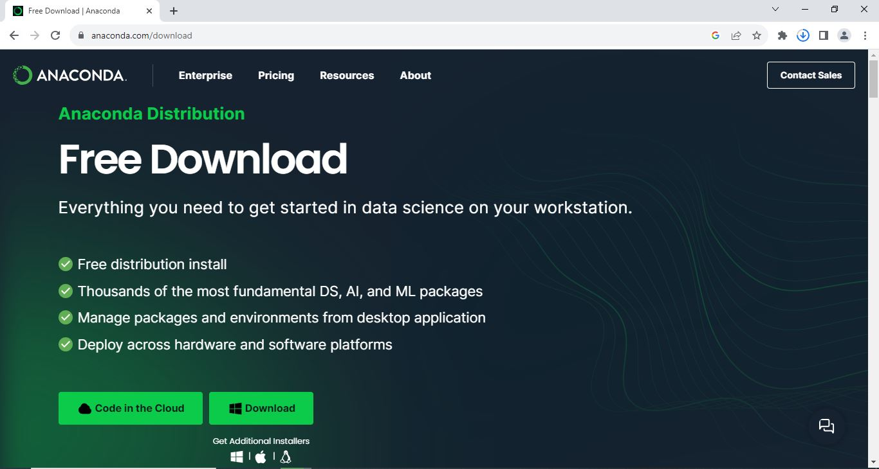

* Open the downloaded setup and complete the installation.

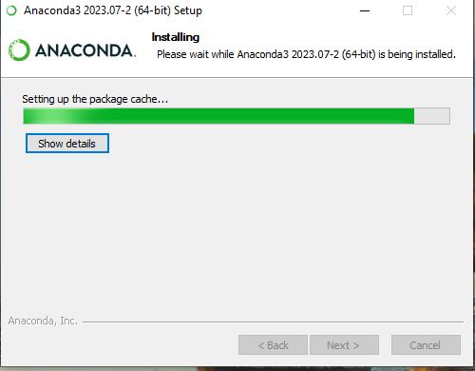

**Setting up IDE for Python:**

* Open Anaconda Navigation and install Jupyter Notebook.
* Open Jupyter Notebook and create new folder.

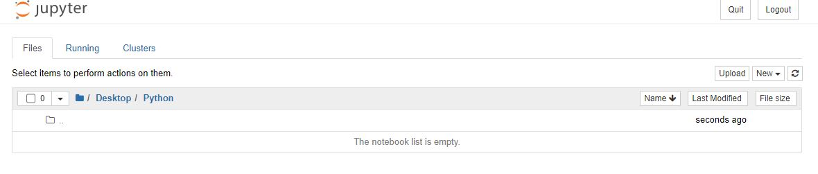

**Install Packages:**

* Open Anaconda Powershell Prompt.
* Write pip install matplotlib.

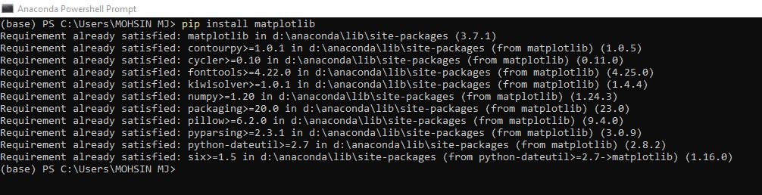

**Create your First Project:**

* 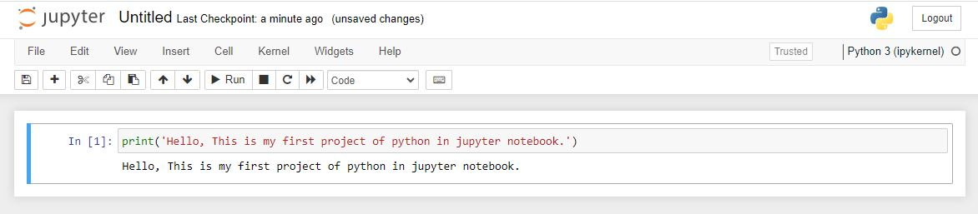Open Jupyter Notebook and write your code in python.